Consumer Behaviour and Marketing Psychology
Assessment 3
Student name:
Student ID:

Executive Summary
This research has explained the need for an efficient marketing strategy in the success of the product. The Pantene has established itself as a market leader, but it has also understood the need for a better consumer understanding, which would be effective in the creation of an efficient marketing strategy. The theories in relation to consumer behaviour have been discussed in details which can be used by Pantene for improving their marketing strategy. The specific target customer base can also be penetrated if the theories are used efficiently. The knowledge gained through analysis of the consumer behaviour can provide unique insights into the mind of the customer and lead to new streams and means of marketing strategies. The engagement of the brand with the customers is improved due to the use of an efficient marketing strategy.

Table of Contents
Selected Product or Service Overview 3
Critical Analysis 3
Strategic Recommendations that are logical and feasible 7
References 9

Selected Product or Service Overview
The product purchasing is highly influenced by consumer behaviour. The preferences and the inclinations of the consumers greatly vary, which must be understood by the companies to better align their products and services (Ottman 2017). The use of various theories and methods for understanding consumer behaviour is thus essential for the success of the company (Ryan 2016). This research aims to find the consumer mentalities to the Pantene shampoo sold by Woolworths. Pantene is a well-known brand with a multinational presence. The feedback of the customers through 10 close-ended questionnaires has helped in understanding the consumer perception regarding the product. This insight can then be applied in the marketing strategy of the shampoo to raise market awareness. The marketing strategy of the Pantene has been effective in increasing the sales volume over the years. But there are improvements which can be made in relation to consumer behaviour. The Pantene has used the marketing strategies in the past to grab significant market share, but the strategies have become insignificant in recent times. Thus, an effective market strategy needs to be developed for the continued growth of the Pantene in the future. It is also required to stay relevant in the market. This project intends to explore the theories which can be used to understand consumer behaviour and also to create an effective marketing strategy for continued consumer delivery. The various factors affecting consumer behaviour has also been included in the research.

Critical Analysis
Consumer behaviour theories and methods can be effectively applied to understand consumer behaviour. This understanding can be applied to the marketing strategy which can be tuned to suit the needs of the customers. There are several theories of understanding consumer behavior such as:
Theory of Reasoned Action
This theory mainly centralizes on the existing attitudes of the decision-making process (Montano & Kasprzyk 2015). The core concept of it is in the behavior of the consumers who are proposed to act in their personal and best interest which can be a basis of assessing the consumer behavior and accordingly the strategies can be adopted by the companies like Pantene to increase the effectiveness of their marketing and product development process. The consumers are considered to be rational in their choice and so their attitude varies from product to product. This is necessarily true for all the products and during their purchase of a product they weigh the various conditions like price, effectiveness, need etc. to ascertain if they want to buy it. This reasoning is the prime basis of this theory. The specificity of the intended results is very important for the decision-making process (Pappas 2016). The consumers always have a specific result in mind when purchasing a product which must be clearly understood by the companies to change the minds of the consumers. If the Pantene intends to increase its sales then they must be able to invade the needs of the customers and the reasons behind it. This will help them to apply the reason in preparing an efficient marketing strategy which will address the cause directly and would enable better penetration of the consumer perception.
The Push and Pull Communication system
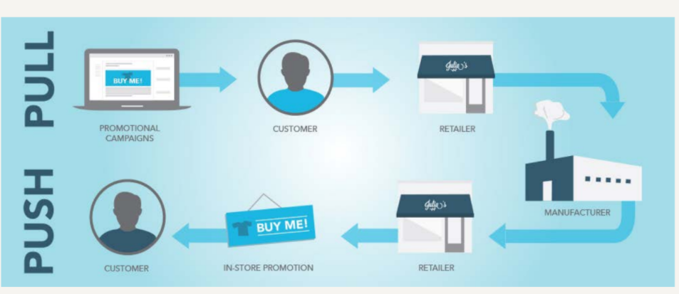
Figure 1: Push and Pull Communication system
Source: (Besta et al. 2017)
This theory is based on a five-step process for identification and analysis of consumer behavior. This theory accepts that there are several factors which influence the consumer which can be internal and external factors (Besta et al. 2017). Thus, an understanding of these factors through a step by step process would lead to better customer understanding which can be applied in the decision making the process. The consumer uses a considerable amount of thought and time to assess the decision of buying the product and judging its positive and negative points to reach a decision (Funk, Alexandris & McDonald 2016). According to this theory, there are two periods in the decision-making process where the consumers can be most influenced. They are at the beginning of the product knowledge by providing relevant information to the customers to sway them in favor of the product. The Pantene has used the point of anti-dandruff in a limited time to be customer specific and effective which has taken the attention of the customers in their favor. The next stage for contribution by the marketers is in influencing the external factors like an advertisement which may also turn the customer opinion. This stage can be used to instil a desire in consumers to buy the product in the future. A combination of the two would impact the consumers into the Pantene. The time in between these two steps the consumers have already in mind what they want and thus can be moved very little into buying. The look, feel, or just the branding may even influence the consumers into buying also if it is not different from the others.
Motivation Need Theory
Maslow's motivation theory specifies the pyramid of five need-based systems which can be applied by the Pantene in their marketing strategies to increase their sales and brand value. The five need-based systems are survival, safety, love, esteem and self-actualization in order of their importance (Velmurugan & Sankar 2017). This hierarchical order can be applied by the Pantene to design their products to better suit their target customers. The Pantene need to establish their product in the need base pyramid to fit the customer demands, and accordingly, it will be reflected in the demand for the product. The marketers need to create artificial importance for the product as the Pantene shampoo is not a necessity, but the marketing strategy has been designed in such a way that the customers feel an urgent need for it. The highlighted fat is stressed on the removal of dandruff or oil control and these specific and intended advertisements incite need in the consumers who buy the shampoo. The marketers can also engineer the strategies to create demand and influence the consumers to align their strategy with the customer inclinations (Montano & Kasprzyk 2015). The uniqueness of the adopted methods is highly responsible for the inclusion of the brand somewhere on the need-based Maslow's pyramid. This theory thus can be effectively used to establish a hierarchical need for the Pantene shampoo and to separate itself from the competitors.
Hawkins Stern Impulse Buying
This theory mainly focuses on the impulse of the consumers rather than on rational action (Shapiro 2015). This theory believes that the consumers are more often very impulsive while buying various products and more so in the case of non-essential products. The main aim of this theory is to cover an aspect which has been ignored but if used in conjunction can lead to better customer understanding. This would help in strategy making as another dimension of consumer behavior is also included. So, the effectiveness of the adopted strategies increases manifold if the impulse can also be controlled, changed or incited whenever required according to the needs of the company (Lee et al. 2015). There are four cases of impulse buying such as direct impulse, reminiscent impulse, suggested impulse and planned impulse. Pantene can forecast the differences between their products and their rivals to paint a picture that would invite the customers into buying their products for the benefits. The impulses can also be included in the marketing strategies to increase the chances of success of the product and the applied strategy.
Thus, the theories can be effectively used for making streamlined strategies for customer targeting as this will lead to better customer understanding which then can be applied to make a marketing and influencing strategy. The marketing issues which can decrease the impact of the marketing strategies can also be reduced or excluded by the application of these theories in the decision-making process. The marketing of the Pantene serves the dual purpose of customer awareness and also to influence the customer attitudes about the product. An effective marketing strategy is thus very essential for the Pantene. Since it is an established brand, the need to change the marketing strategy is also required to change the approach for the marketing of the product and to overcome the market saturation (Shih et al. 2019). The factors influencing the customers like the culture, society, attitudes can also be affected by the use of sound marketing strategy. The factors which motivate the customers into buying or what they prefer can also be understood by the consumer behavior analysis. Then, the Pantene can align their marketing strategy to distribute the relevant knowledge to the customers. Pantene should realize the changing notion of the product is not limited to only the effective marketing strategy but there are several other factors which prod the consumer’s behavior. This knowledge can then be applied in the organizational framework for improved and renewed marketing strategy.

Strategic Recommendations that are logical and feasible
The recommendations for applying the theories in Pantene marketing strategy are as follows:
- Data Analysis: The marketing team of Pantene must continuously collect data regarding the product from the market. The consumer views and opinions would reflect the sentiments of them and then the marketers can analyze the data to understand the possible factors which are reducing the effectiveness of the product in the market. This data analysis would also enable the marketers of Pantene to change their approach as and when required to suit better the customer needs and demands when purchasing in the Woolworths website. The varying opinion of the customers along with their needs can also be reflected in the analysis of the data (Haben, Singleton & Grindrod 2015). The result of the analysis can also induce necessary changes in the decision-making process or on the approach of marketing to increase market penetration (Waldron et al. 2016). The extent of the success of the adopted marketing strategy can also be assessed by it. This would increase and open newer channels for reaching target customers and also pass a relevant message through the marketing mediums. The analysis will also shed light on the fact if an entire change of the marketing strategy is required by Pantene.
- New Possibilities: The awareness of the customer's behavior would also mean the company is aware of any new possibilities or demands of the customers (Revilla-Camacho, Vega-Vázquez & Cossío-Silva 2015). When there is a shift in the basic opinion of the customers, it can be utilized by the companies to develop or make necessary changes to the product approach. The consumer behaviors are also a metric on which the newer trends of the market can be achieved or understood. The company also needs to be persistent in their approach and consistently remind the customers of the products and carve a niche for itself by targeting requirement specific customers which can only be done by understanding the customer behaviour. A considerable and planned marketing strategy would also increase exposure and open up fresh market segments for use. The market opportunities can also be explored if the attitudes of the consumers can be understood by the application of the theories.
- Specific Business Goals: A better understanding of customer behaviour would help the company informing the targets and aims of the company it is trying to achieve. A clear expression of the aims and objectives of the company would also be beneficial for strategies which then can be aligned with the marketing strategy. The Pantene needs to identify the goals which it intends to achieve so that the marketing team can formulate their marketing strategies to meet the aims and objectives. The entire project strategy would also be highly dependent on the goals that are set by the management (Olsen et al. 2016)
- Buyer-Centric Marketing Strategy: The marketing strategy should be more than just the tools for means of branding. The relevant effects of the strategy can also be gauged by understanding consumer behaviour (Ali, Ilyas & Abdul Rehman 2016). The influence which can be observed on the customers can be used to understand if the strategies have affected the customers. Thus, a more customer-centric strategy needs to be developed to increase sales. The customer behaviour understanding can be used to understand the factors which motivate the consumers and what the consumers prefer, which then can be used to the advantage of Pantene. The application of the theories would increase the effectiveness of marketing strategies.

